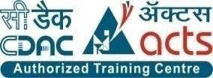

**INSTITUTE FOR**

**ADVANCE COMPUTING**

**AND SOFTWARE DEVELOPMENT AKURDI,**

**PUNE**

Documentation On

**DAIRY DELIGHT**

**“Online Dairy Products E-commerce Store”**

PG-DAC SEP 2022

Submitted By:

**Group No: 76**

**Namita Dewangan (229174)**

**Kavita (229162)**

**Mrs. Rupali Thorat Mr. Rohit Puranik**

**Project Guide Centre Coordinator**

**Table of Contents**

1. **Introduction ............................................................................................................................... 2**

Problem Statement ................................................................................................................. 3

Aim & Objectives .................................................................................................................. 3

1. **Overall Description .................................................................................................................... 4**

Proposed Methodology .......................................................................................................... 4

Operating Environment .......................................................................................................... 4

Design and Implementation Constraints ................................................................................ 5

1. **Requirements Specification ...................................................................................................... 6**

External Interface Requirements ............................................................................................ 6

1. **System Diagram ......................................................................................................................... 7**

Activity Diagram.................................................................................................................... 7

Data Flow Diagram .............................................................................................................. 10

Class Diagram ...................................................................................................................... 15

Use Case Diagram ............................................................................................................... 18

ER Diagram ......................................................................................................................... 21

1. **Table Structure ........................................................................................................................ 22**

Course .................................................................................................................................. 22

Subject ................................................................................................................................. 23

Admin Student ..................................................................................................................... 24

Student ................................................................................................................................. 25

Admin Faculty ..................................................................................................................... 26

Faculty ................................................................................................................................. 26

Assignments ........................................................................................................................ 26

Notes .................................................................................................................................... 27

Classroom ............................................................................................................................ 27

Daily Schedule ..................................................................................................................... 28

Placements ........................................................................................................................... 28

Announcement ..................................................................................................................... 29

Contact Number ................................................................................................................... 30

User ...................................................................................................................................... 30

1. **Conclusion ................................................................................................................................ 31** Future Scope ........................................................................................................................ 31
2. **References ................................................................................................................................. 32**

**1. INTRODUCTION**

**Introduction:**

This project is a web-based shopping system for an existing shop. An Online dairy Product E-commerce System where the Admin can Add, Update and Delete products. The Products are divided into various categories like Milk, Butter, Paneer, etc. A user can select a particular item to view the details, choose the number of items and fill in details like name etc. to buy a product. The project objective is to deliver the online shopping application into web platform. Online shopping is the process where consumers directly buy products or services from a seller in real- time, without an intermediary service. This project is attempt to provide the advantages of online shopping to customers of a real shop. It helps buying the products in the shop anywhere through internet by using an android device. Thus, the customer will get the service of online shopping and home delivery from his favourite shop.

The objective of the project is to make an application in android platform to purchase items in an existing shop. In order to build such an application complete web support, need to be provided. A complete and efficient web application which can provide the online shopping experience is the basic objective of the project. The web application can be implemented in the form of an android application with web view.

**Features**:-

1. Products Available- Milk, Paneer, Butter, Lassi.

2. Search for Products (Milk, Butter) products easily

3. Category of products- Milk, Butter, Paneer, Lassi,

4. Cart feature

5. Date and time of product delivery will be notified by the system

6. The admin can add/delete Products.

7. Allows the customers to Order items.

**2.Aims and Objective:**

The objective of the project is to make an application in android platform to purchase items in an existing shop. In order to build such an application complete web support, need to be provided. A complete and efficient web application which can provide the online shopping experience is the basic objective of the project. The web application can be implemented in the form of an android application with web view.

**Project Overview:**

The central concept of the application is to allow the customer to shop virtually using the internet and allow customers to buy the items and articles of their desire from the store. The information pertaining to the products are stores on an RDBMS at the server side (store).

The server processes the customers, and the items are shipped to the address submitted by them. The application was designed into two modules first is for the customers who wish to buy the articles. Second is for the storekeepers who maintains and updates the information pertaining to the articles and those of this product is a departmental store where the application is hosted on the web and the administrator maintains the database. The application, which is deploy the customer database, the details of the items are brought forward from the database for the customer view based on the selection through the menu and the database of all the products are updated at the end of each transaction. Data entry into the application can be done through various screens designed for various levels of users. Once the authorized personal feed the relevant data into the system, several reports could be generated as per the security.

**Project Scope:**

This system can be implemented to any shop in the locality or to multinational branded shops having retail outlet chains. The system recommends a facility to accept the orders 24X7 and a home delivery system which can make customers happy. If shops are providing an online portal where their customers can enjoy easy shopping from anywhere, the shops won’t be losing any more customers to the trending online shops such as FlipKart or eBay. Since the application is available and always available.

**Operating Environment:**

Server Side:

**Processor:** Intel Pentium

**HDD**: Minimum 500GB Disk Space

**RAM:** Minimum4GB

**OS**: Windows 10 and above

**Database:** MySQL

Client Side(minimum requirements):

**Processor:** Intel Dual Core

**HDD:** Minimum80GB Disk Space

**RAM:** Minimum 2GB

**OS:** Windows 7 and above

**Design and Implementation Constraints:**

* The application will use JavaScript, jQuery and CSS as main web technologies.
* HTTP and FTP protocols are used as communication protocols. FTP is used to upload the web application in live domain and the client can access it via HTTP protocol.
* SMTP protocol is used for Email communication.
* Several types of validations make this web application a secured one and SQL Injections can also be prevented.
* Since Dairy Delight is a web-based application, internet connection must be established.
* Dairy Delight will be used on PCs and will function via internet or intranet in any web browser.

**3. Requirements Specification**

**External Interface Requirements:**

User Interfaces:

* All the users will see the same page when they enter in this website. This page asks the users a username and a password.
* After being authenticated by correct username and password, user will be redirect to their corresponding profile where they can do various activities.
* The user interface will be simple and consistence, using terminology commonly understood by intended users of the system. The system will have simple interface, consistence with standard interface, to eliminate need for user training of infrequent users.

Hardware Interfaces:

* No extra hardware interfaces are needed.
* The system will use the standard hardware and data communication resources.

This includes, but not limited to, general network connection at the server/hosting site, network server and network management tools.

Application Interfaces:

**Web Browser:**

The system is a web-based application; clients need a modern web browser such as Mozilla Firebox, Microsoft Edge, Opera and Chrome. The computer must have an Internet connection in order to be able to access the system.

Communications Interfaces:

* This system uses communication resources which includes but not limited to, HTTP protocol for communication with the web browser and web server and TCP/IP network protocol with HTTP protocol.
* This application will communicate with the database that holds all the booking information. Users can contact with server side through HTTP protocol by means of a function that is called HTTP Service. This function allows the application to use the data retrieved by server to fulfil the request fired by the user.

**4. System Diagrams**

* **Activity Diagram:**
* Registration Activity:

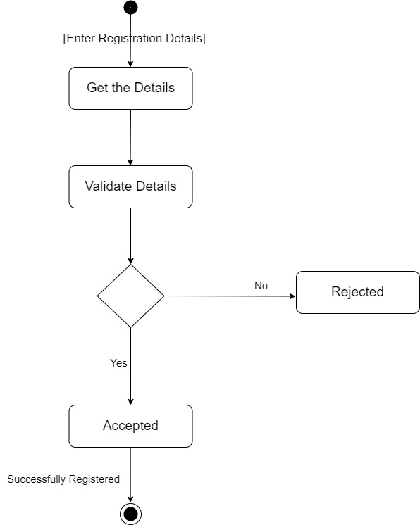

* Login Activity:

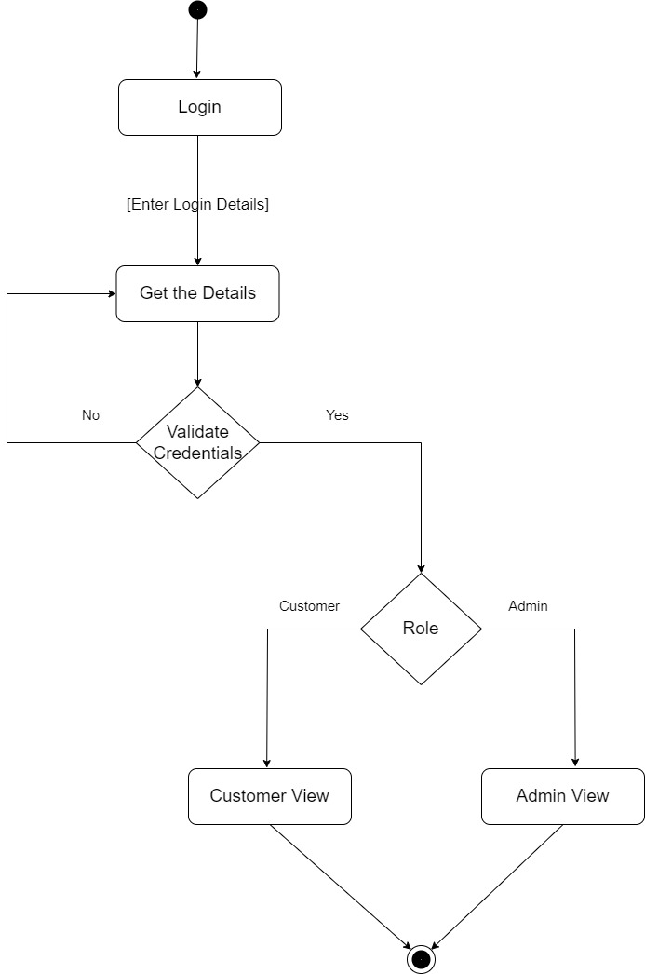

* Search Item Activity:

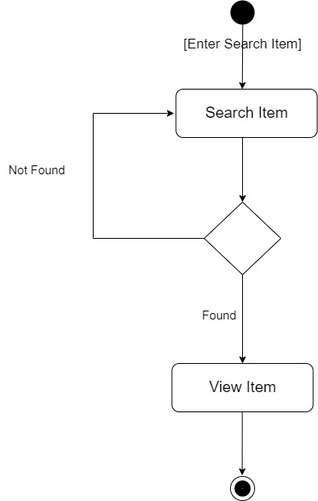

* Add to cart Activity:

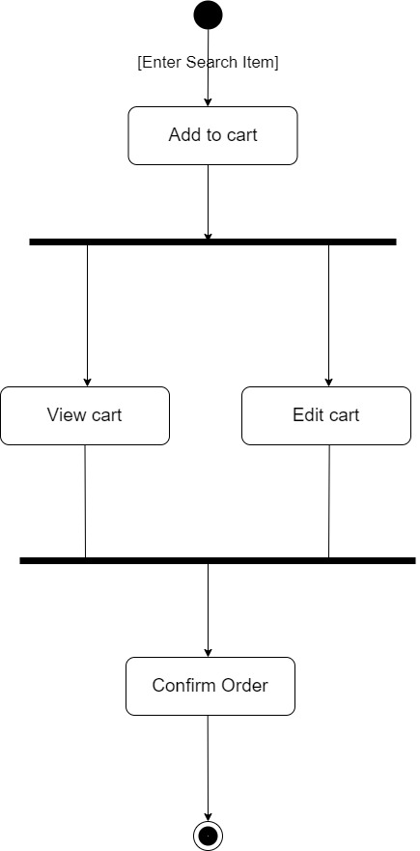

* Payment Activity:

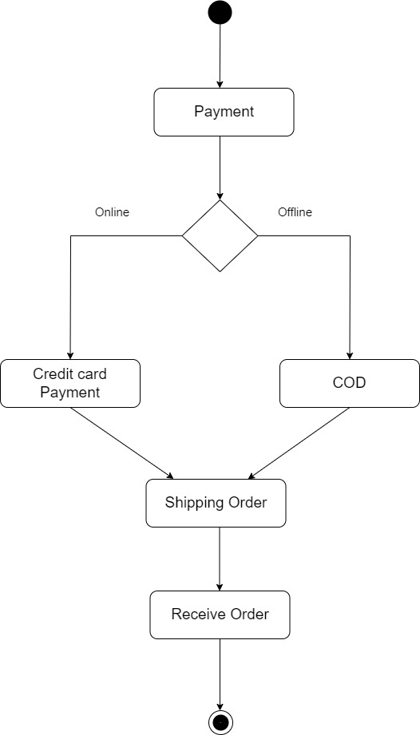

**0th Level DFD:**

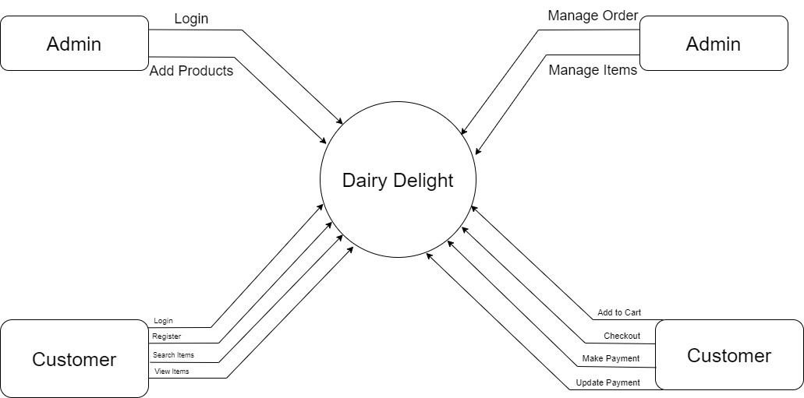

**UseCase Diagram**

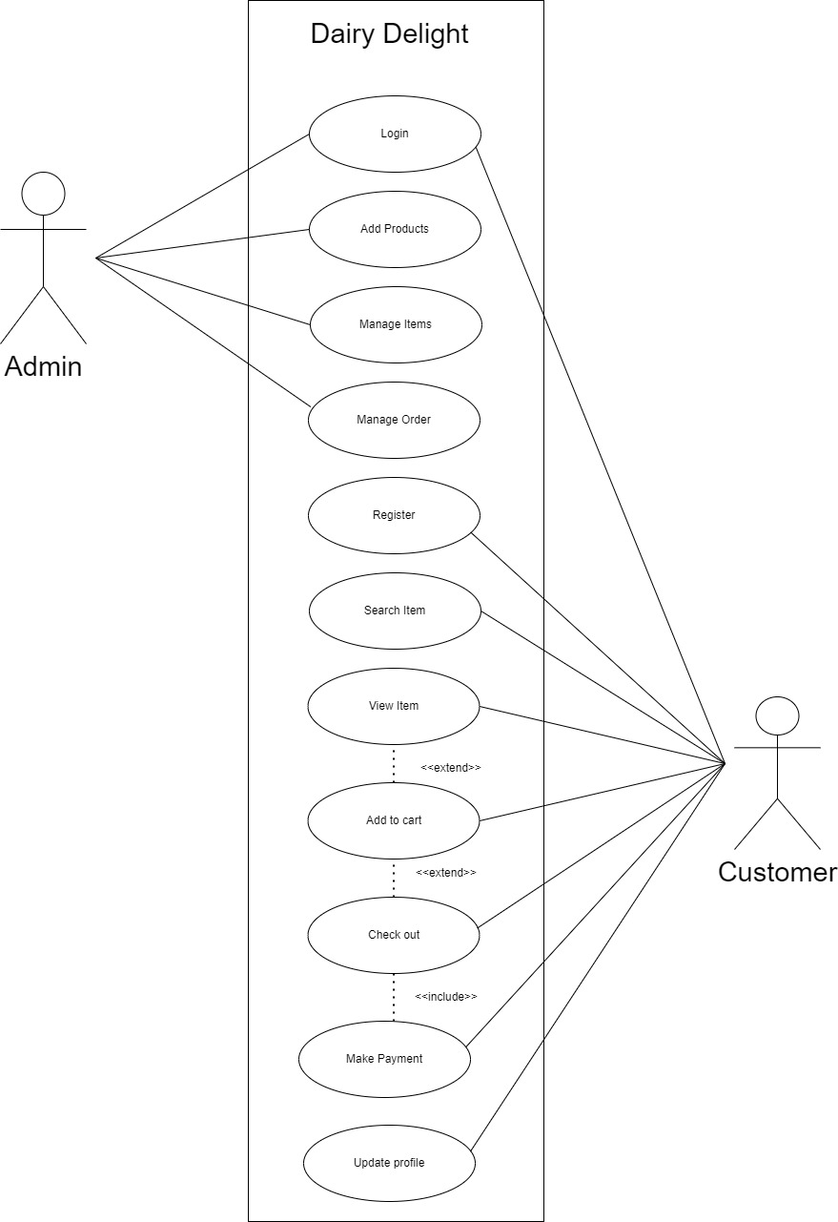

**Sequence Diagram:**

**Search item in catelog**

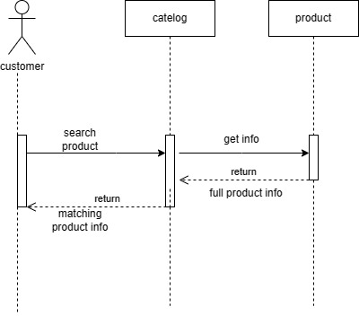

**Add item into cart**

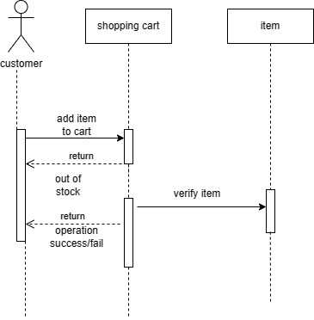

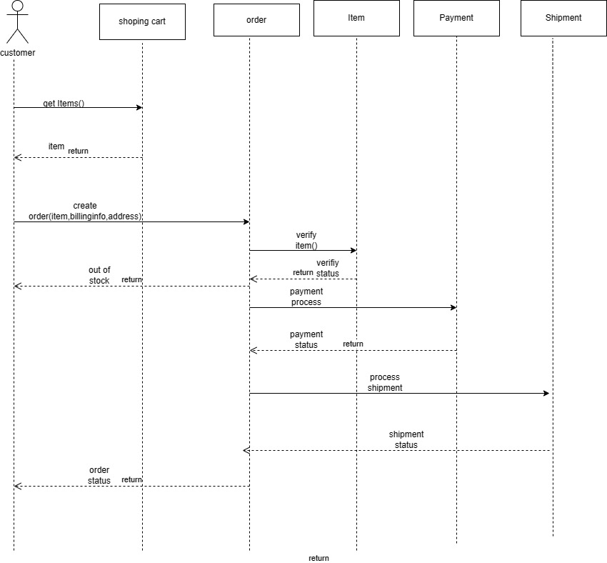

Class Diagram:

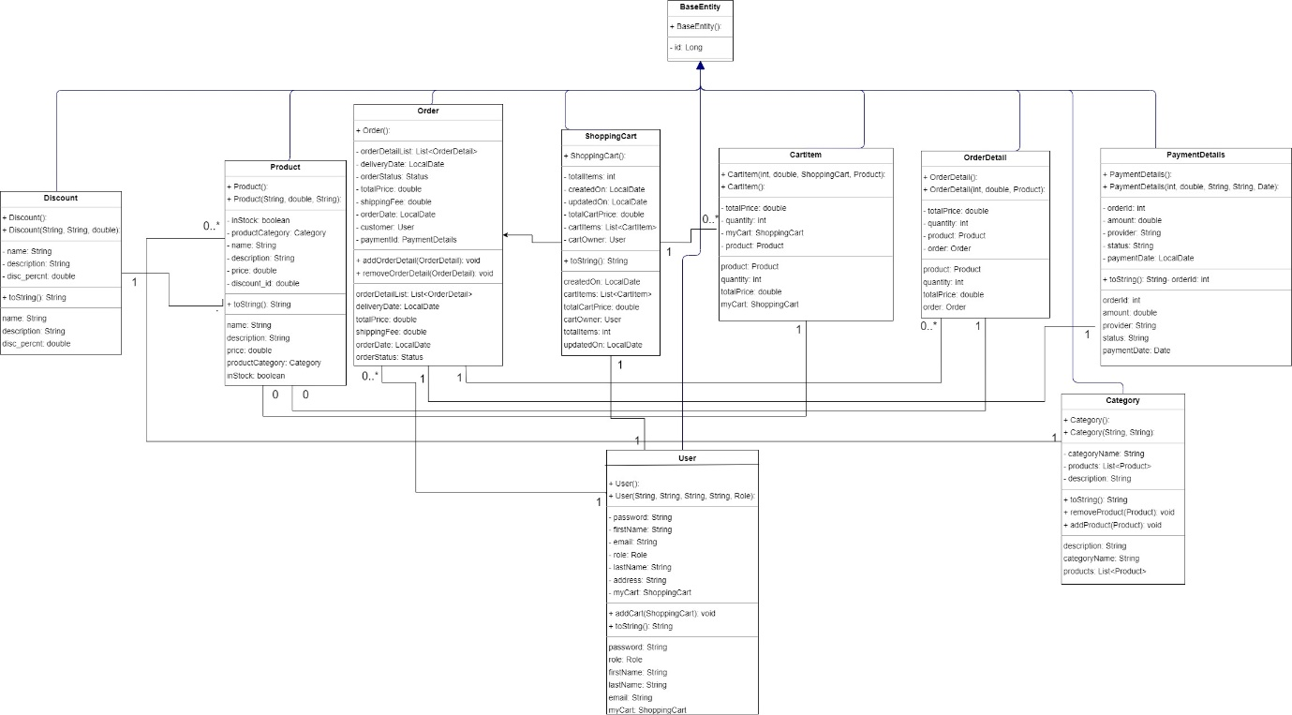

E-R Diagram:

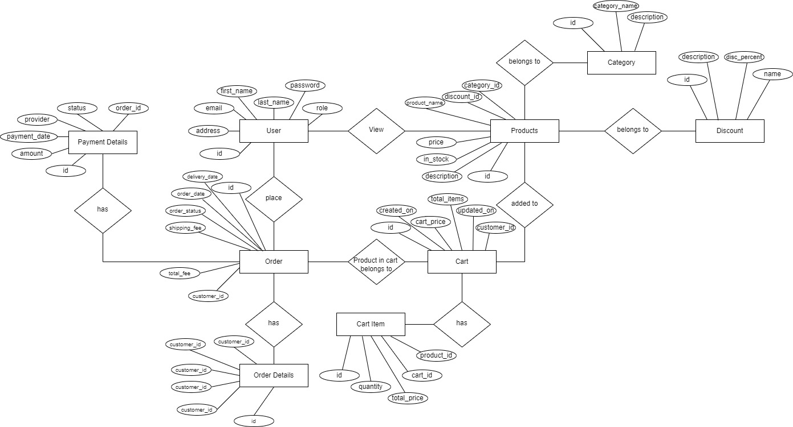

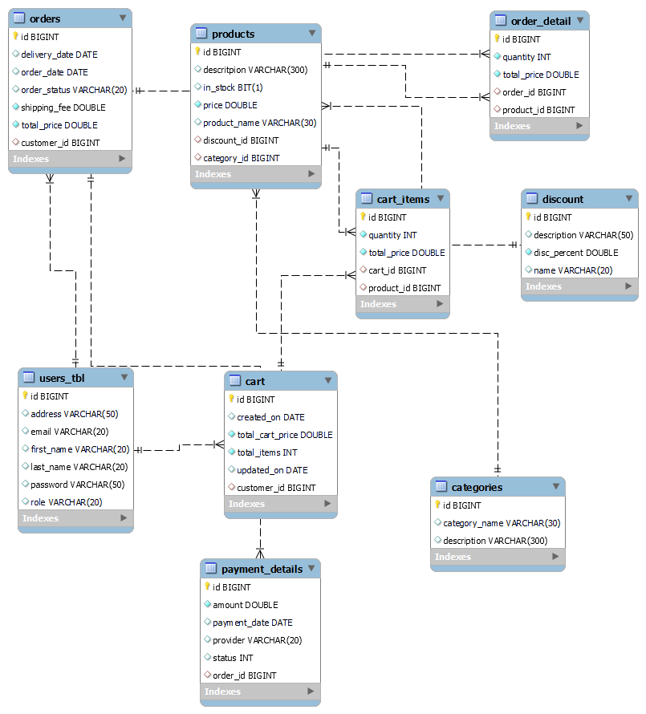

**Deployment Diagram**

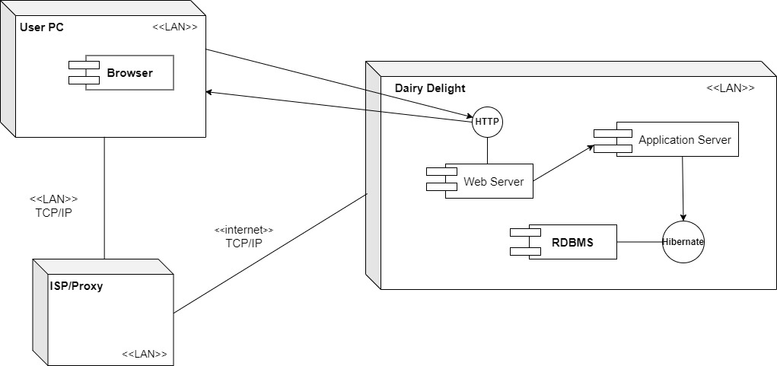

**Database Table Structure**

User table:

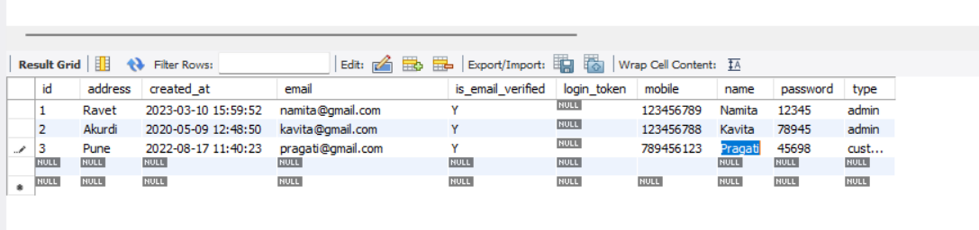

Category Table:

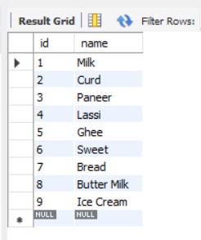

Products Table:

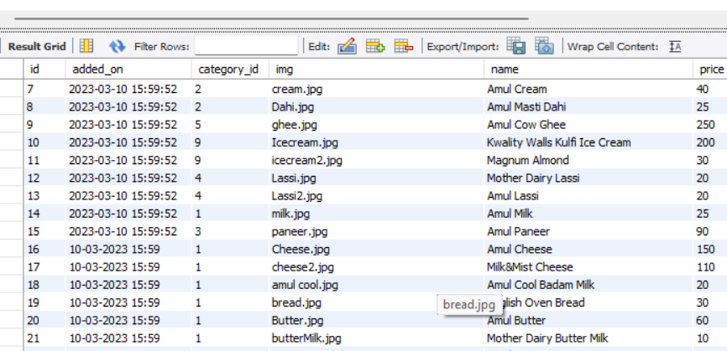

Add to cart:

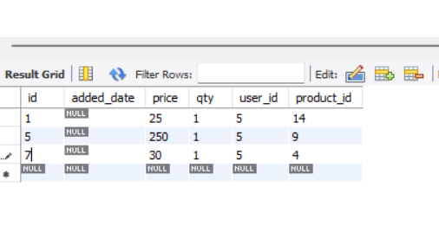

Orders:

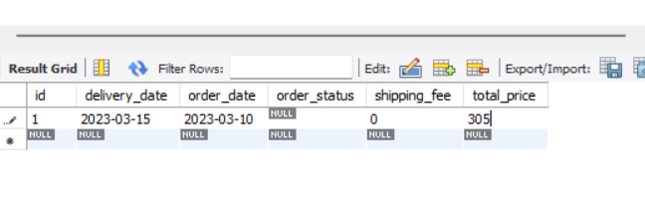

Order Details:

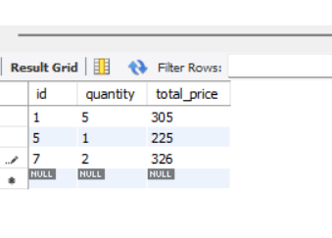

Checkout cart:

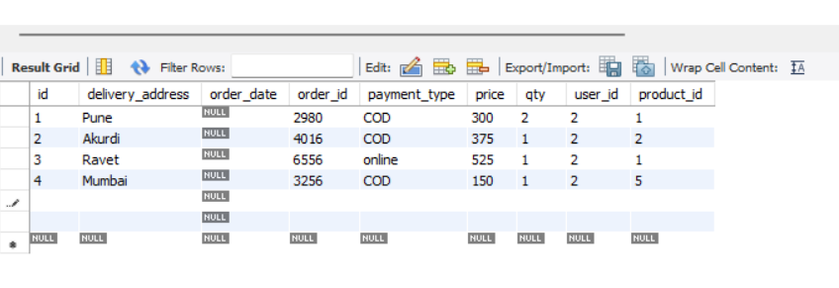

Payment Details:

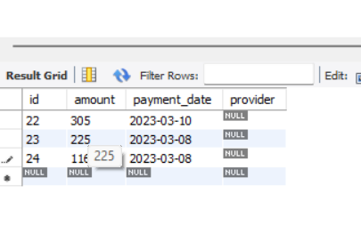

**Screenshots:**

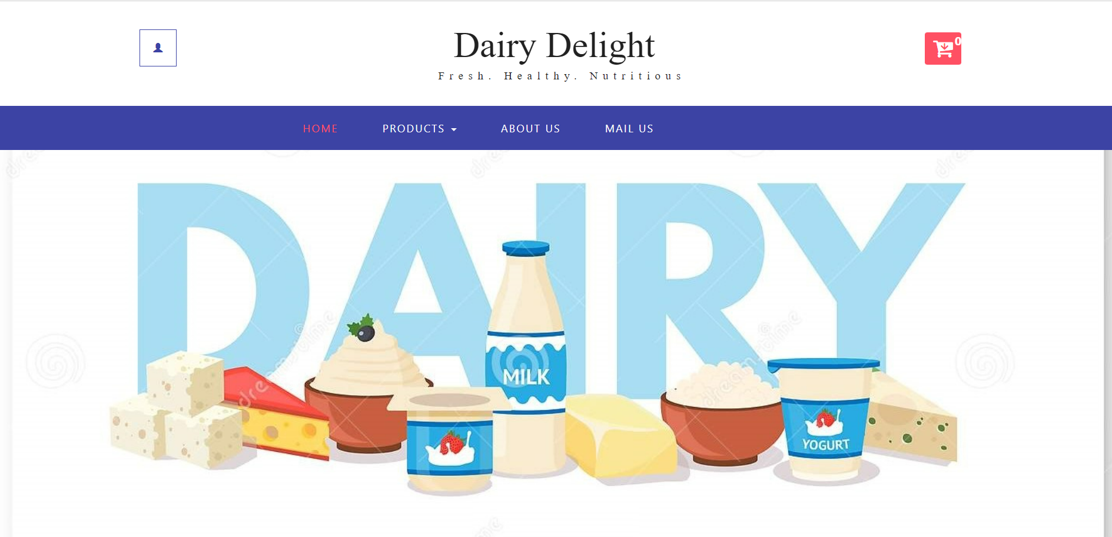

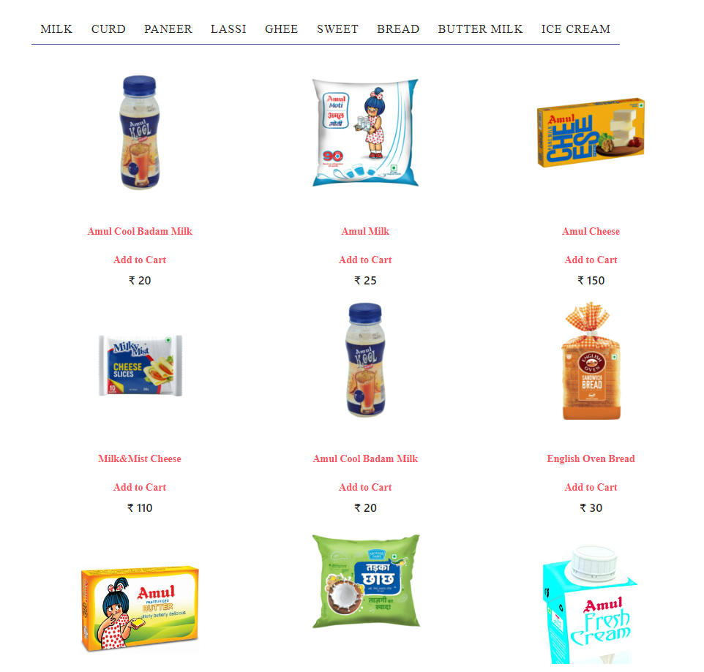

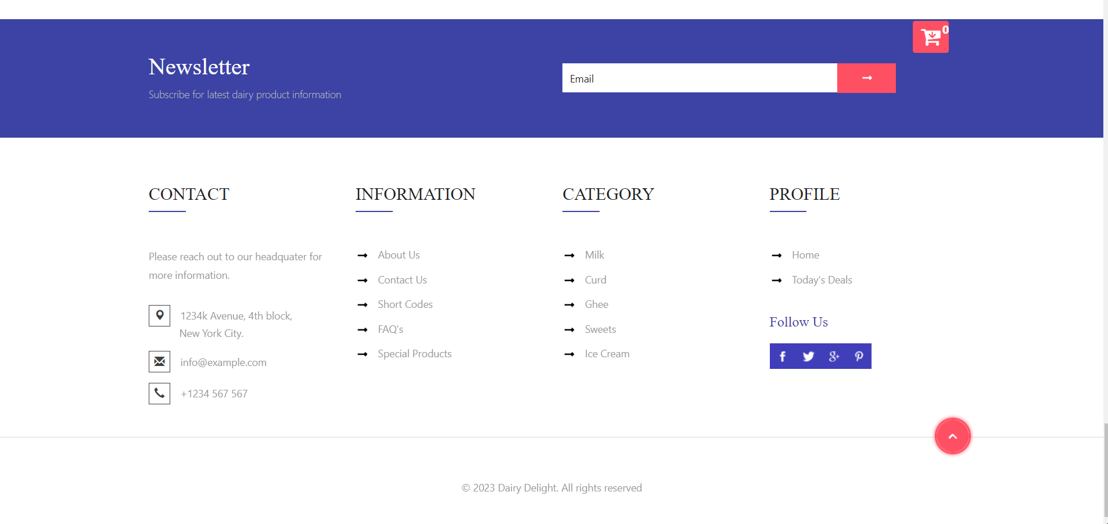

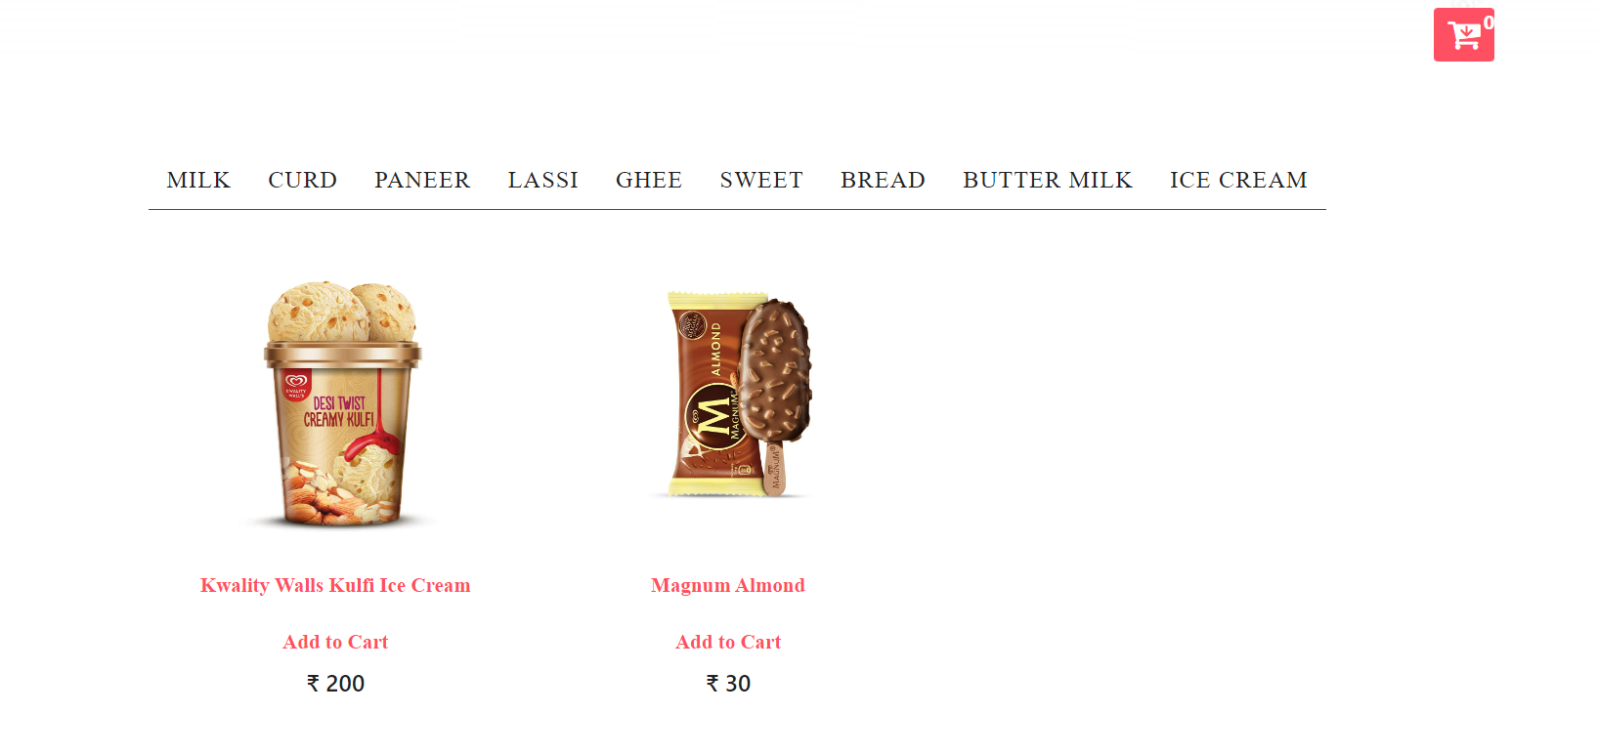

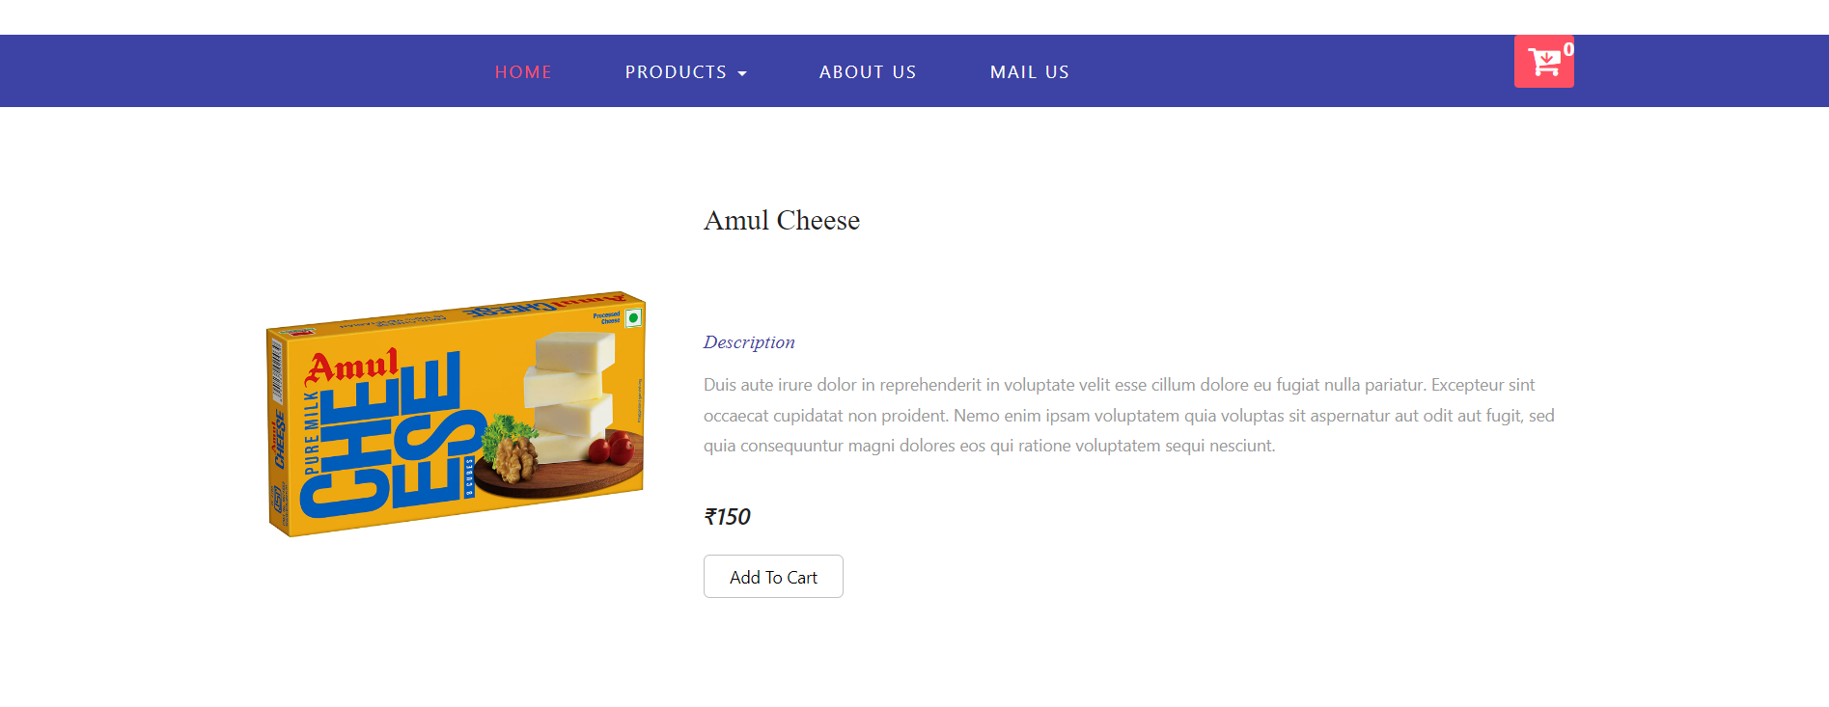

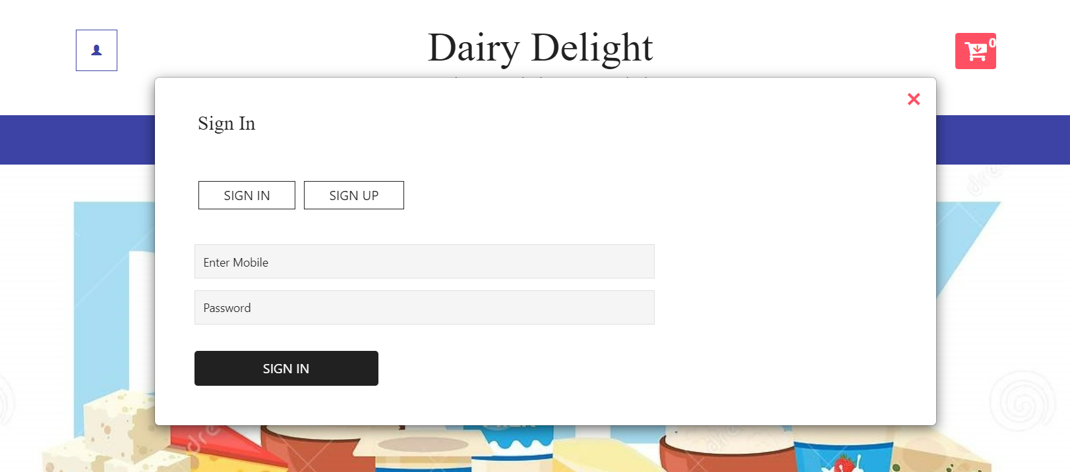

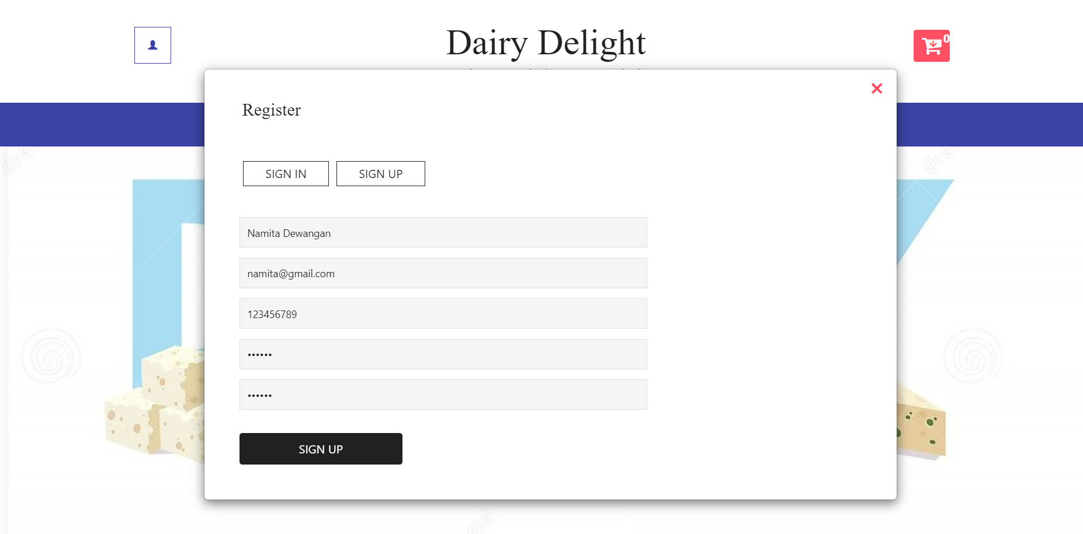

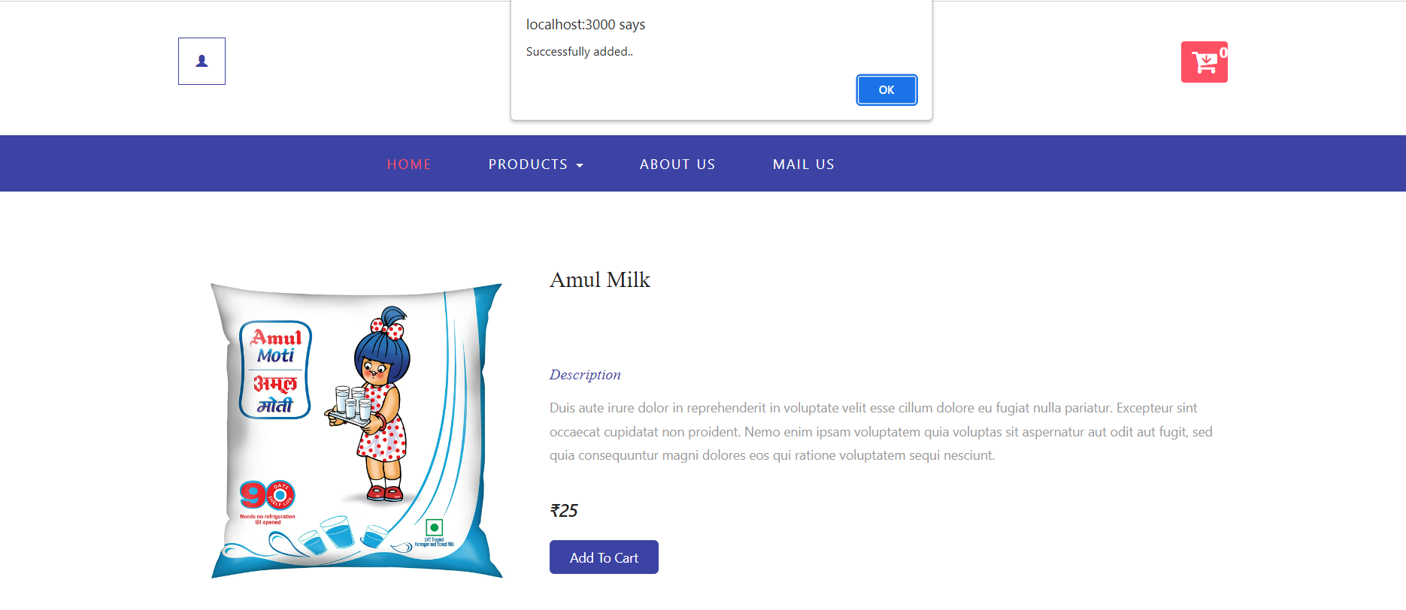

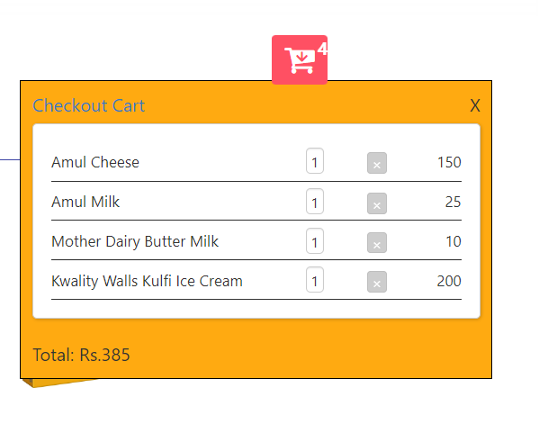

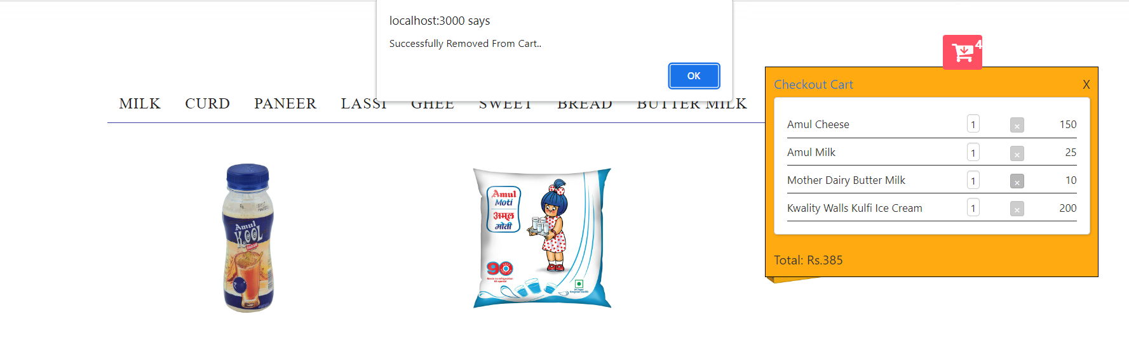

**6. CONCLUSION**

* **Conclusion:**

This project aid in automating the existing manual system. This is a paperless work. It can be monitored and guarded remotely. It cut down the man power required and provides accurate information. All years together huddled information can be saved and can be accessed at any time. For this reason, the data stored in the repository helps in taking decision by management. So, it is improved to have a Web Based system. All the stakeholders, faculty and authority can get the required information without delay. This system is crucial in the colleges and universities.

* **Future Scope:**

This project can be enhanced further by adding payable additional courses, online feedback system, online payment facility for the members to reduce the extra work of the admin. The software is flexible enough to be modified and implemented as per future requirements. We have tried our best to present this free and user–friendly website to Institute.

**7. REFERENCES.**

**References:**

* <http://www.ijcstjournal.org/volume-7/issue-1/IJCST-V7I1P4.pdf>

 <https://bootstrapmade.com/mentor-free-education-bootstrap-theme/>

 <https://www.javatpoint.com/java-mail-api-tutorial>

 https://[angular.io/docs](https://angular.io/docs)

* [https://javaee.github.io/javaee-spec/javadoc](https://javaee.github.io/javaee-spec/javadocs)[s/](https://javaee.github.io/javaee-spec/javadocs/)

 <https://www.w3schools.com/>